- This week's labour market and inflation releases reported continued stickiness in the Bank of England's favoured measure of inflation and in pay growth. Evidence on the likely impact of this month's national insurance and national living wage rises has been mixed. Redundancy notifications remain low, but vacancies and the number of payrolled employees fell in March.
- Recent US tariff announcements will act as a demand shock to the UK economy, and the case for loosening monetary policy more quickly than we previously anticipated is strong. But to make that happen, the Monetary Policy Committee would need to overlook its concerns about supply weakness – given the stickiness of pay growth, it's far from certain the MPC will do this.
In a rare week without US tariff announcements, the domestic data took centre stage. The labour market and consumer prices releases were the Monetary Policy Committee's last chance to get a handle on price and pay pressures ahead of the May meeting.
On the face of it, the inflation release was largely good news. The CPI measure fell to 2.6% in March from 2.8% in February, in line with our expectations but a touch below the consensus forecast. But the MPC's favoured measure of underlying pressures, which excludes indexed and volatile components, rent, and foreign holidays from services inflation, remained stubbornly high. Indeed, most of the downward momentum appears to have faded since the end of last year (Chart 1).
This is largely a function of the recent strength of wage growth, with this week's labour market release reporting services regular pay growth of just below 6% in the three months to February. Previously the Office for National Statistics had flagged that it would make exceptional revisions to its estimates of pay growth to incorporate late and updated returns for one firm that we now know is in the distribution sector. We thought this might bring the official measures of pay growth closer to other softer indicators. But in the event, pay growth is now estimated to have been even stronger in late-2024.
Chart 1: Measures of underlying services inflation remain stubbornly high
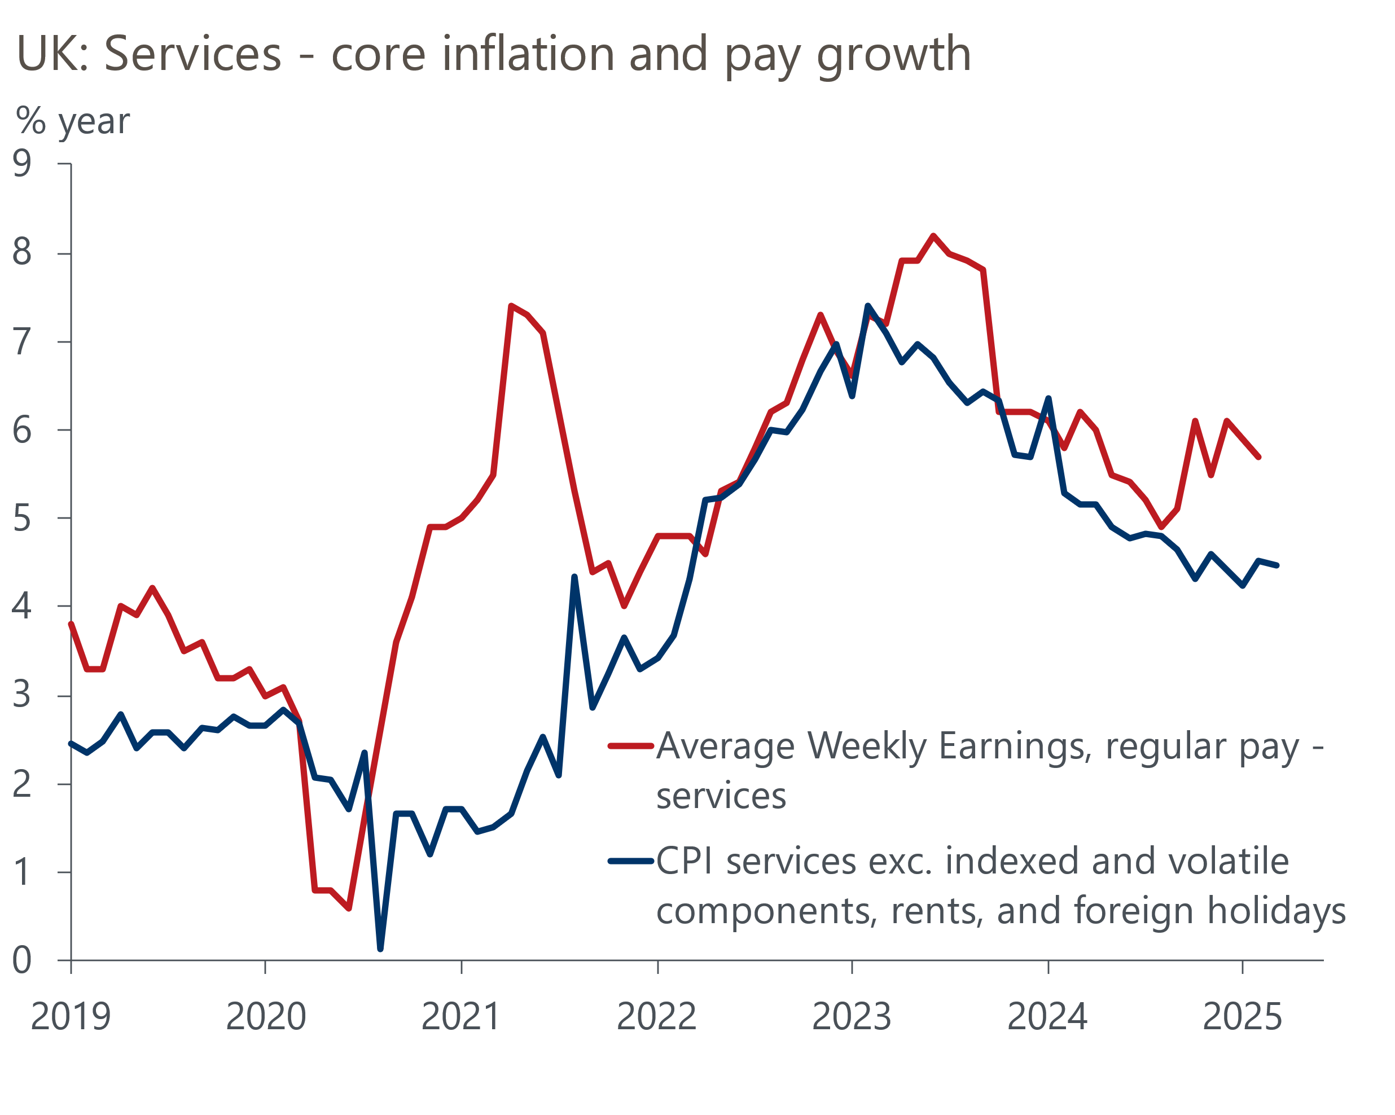
Source: Oxford Economics calculations using data from Haver Analytics

The key data on pay and prices is still to come. With higher energy prices set to add 0.7ppts on its own, inflation will almost certainly surge in April. The main uncertainty is around the scale of the rise in other regulated and indexed prices. There's a host of prices that change once a year in April, and in recent years large April increases have played a key role in keeping inflation high for the rest of the year.
Forecasting the scale of these rises is very difficult. On the one hand, we know that water bills have risen by an average of 26% this month. But on the other hand, items such as phone contracts are uprated by inflation plus a fixed amount and so should see smaller rises this year because inflation was lower in 2024 than in 2023. There are also strong negative base effects to factor in – services prices rose 1.5% month-on-month in April 2024, much higher than the median April increase of 0.9% over the past decade.
Given regulated and index prices are inherently backward looking, the MPC has increasingly favoured an inflation measure that excludes these categories. The MPC's focus will be on signs of how April's rises in national insurance contributions and the national living wage are affecting price and wage setting and employment. But the committee will have to wait until its August meeting before it has enough hard data to start forming firm conclusions on the impact.
The little data we have so far covers the period between the announcements of the rises in NICs and the NLW and the policies going into force. Firms planning to dismiss 20 or more employees must submit HR1 forms to the Insolvency Service, and the number of employees covered by HR1 forms submitted recently has only been slightly higher than the 2024 average. But other data have been softer. Most notably the number of unfilled vacancies renewed its decline in the three months to March, after stabilising around the turn of the year. And HMRC data on the number of employees on payrolls showed the biggest month-on-month fall in 11 months in March. But we know that the HMRC measure tends to be heavily revised, and that in recent years those revisions have tended to be upwards, so it would be very premature to conclude the increase in costs was causing a major softening in labour demand (Chart 2).
Chart 2: Past experience suggests March's weak payrolls outturn could be revised up
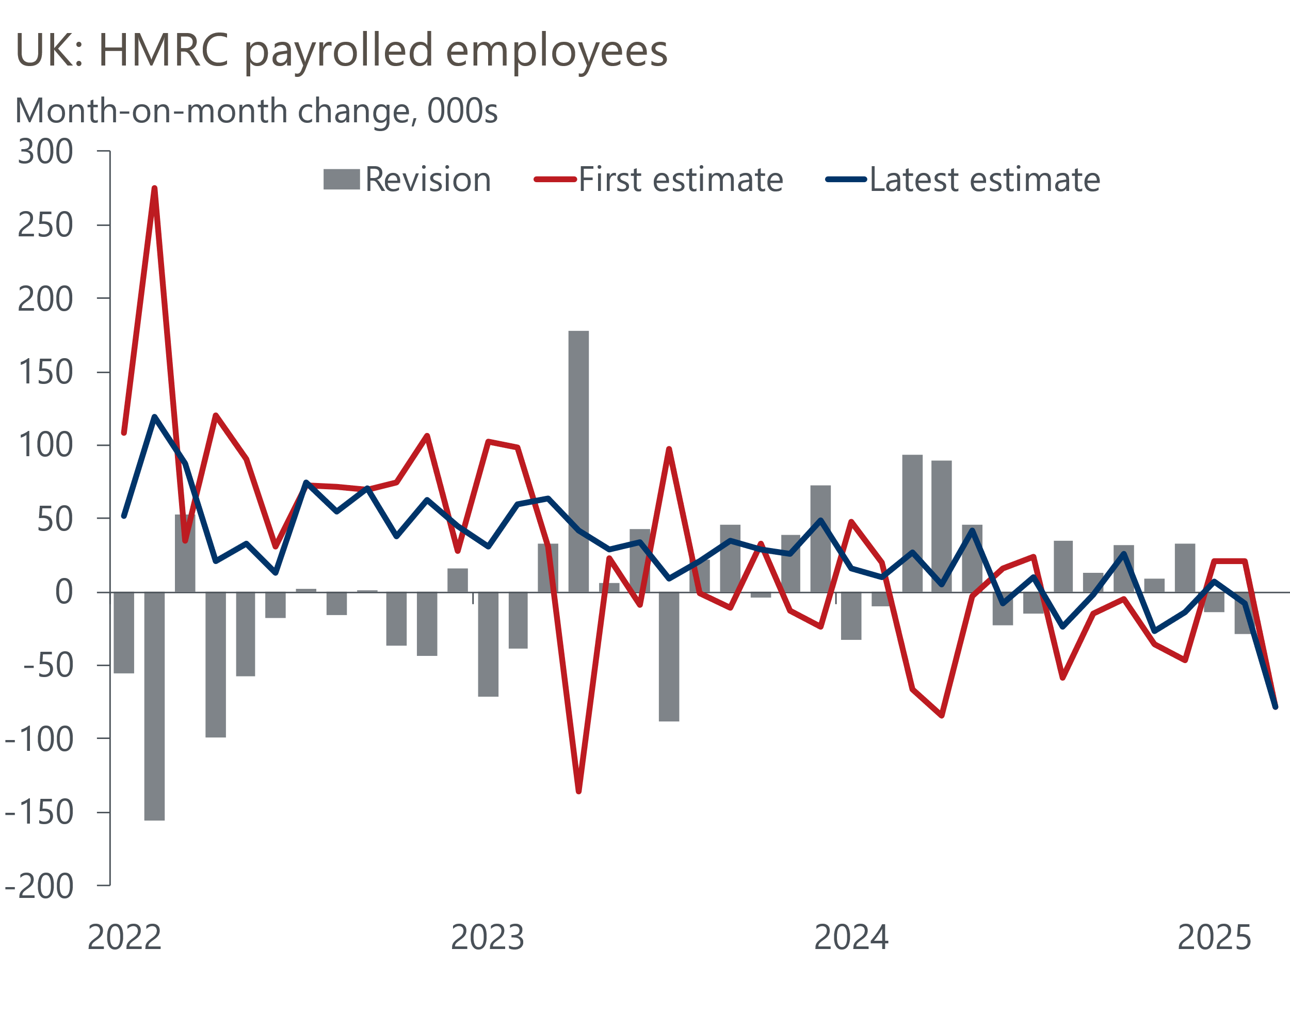
Source: Oxford Economics calculations using data from ONS
The resilience of pay and underlying inflationary pressures create a big dilemma for the MPC. As we argued in a recent note setting out the revisions to our forecasts, US tariff announcements will act as a demand shock for the UK economy and the case for loosening monetary policy more quickly than we previously anticipated is strong. But to make this happen, the MPC would need to overlook its concerns about supply weakness. It's far from certain that the MPC will do this.
Thus far MPC members have been willing to comment on the negative growth implications of US tariffs but not on the impact of inflation. This could yet change – several MPC members are due to speak at the IMF spring meetings in Washington next week. But for the time being, we think the MPC is likely to maintain a relatively cautious approach to loosening policy, continuing the cut-hold tempo at least until it has more evidence on the impact of the NICs and NLW increases.

The week ahead
There's been a wide divergence between hard and soft data of late, which we attribute partly to seasonal adjustment problems with official data and partly to survey data being swayed by a series of events that have rocked sentiment. We think the latter effect will likely drag the flash PMIs down in April given the chaos unleashed by US trade policy announcements in recent weeks and that the increase in employers' national insurance contributions has now gone into effect. We forecast the composite PMI will drop by 1.5pts to 50.0 but there's huge uncertainty around this call.
By contrast, retail sales data have been affected by seasonal adjustment problems. Successive very strong readings in January and February suggest there's likely to be some payback in the March data, with February's readings for the non-food and non-store sectors looking particularly high. We pencil in a 1.1% month-on-month fall in retail sales in March.
Table 1: Week ahead calendar
Date | Events | Period | Measure | Unit | Previous | Forecast
Apr 23 | Public finances | Apr | PSNB ex | £bn | 10.7 | 20.0
Apr 23 | S&P Global manufacturing | Apr | PMI | % bal | 44.9 | 43.0
Apr 23 | S&P Global services | Apr | PMI | % bal | 52.5 | 51.0
Apr 23 | S&P Global composite | Apr | PMI | % bal | 51.5 | 50.0
Apr 25 | GfK consumer confidence | Apr | Headline | % bal | -19 | -21
Apr 25 | Retail sales inc fuel | Mar | m/m | % | 1.0 | -1.1
Apr 25 | Retail sales inc fuel | Mar | y/y | % | 2.2 | 1.0
Source: Oxford Economics

Key forecasts
Table 2: UK forecast overview
(Annual percentage changes unless specified)
 | 2022 | 2023 | 2024 | 2025 | 2026 | 2027
GDP | 4.8 | 0.4 | 1.1 | 1.0 | 0.9 | 1.3
Private consumption | 7.3 | 0.5 | 0.6 | 1.2 | 1.1 | 1.2
Fixed investment | 5.1 | 0.3 | 1.5 | 1.0 | 1.0 | 1.6
Government consumption | 0.6 | 1.6 | 3.0 | 2.3 | 1.2 | 1.5
Exports of goods and services | 12.6 | -0.4 | -1.2 | 0.6 | -1.2 | 1.2
Imports of goods and services | 13.0 | -1.2 | 2.7 | 0.8 | -0.4 | 1.1
Industrial Production | -6.4 | -0.8 | -1.2 | -0.2 | -0.3 | 0.7
Consumer prices | 9.1 | 7.3 | 2.5 | 3.0 | 2.4 | 2.3
Unemployment rate (%) | 3.8 | 4.1 | 4.3 | 4.6 | 4.9 | 4.8
Current a/c balance (% of GDP) | -2.2 | -3.5 | -2.7 | -2.6 | -2.8 | -2.6
Government balance (% of GDP) | 4.3 | 5.2 | 5.0 | 3.5 | 3.3 | 2.7
Central bank policy rate (%, EOP) | 3.50 | 5.25 | 4.75 | 3.75 | 3.00 | 2.50
10yr govt. bond yield (%, EOP) | 3.67 | 3.54 | 4.57 | 4.54 | 3.95 | 3.44
Exchange rate (US$ per £, EOP) | 1.20 | 1.27 | 1.25 | 1.29 | 1.29 | 1.29
Exchange rate (euro per £, EOP) | 1.13 | 1.15 | 1.21 | 1.17 | 1.17 | 1.17
Source: Oxford Economics
Table 3: Quarterly forecasts for the UK
 | 2025 |  |  |  | 2026
 | Q1 | Q2 | Q3 | Q4 | Q1 | Q2 | Q3 | Q4
GDP (% year) | 1.1 | 0.9 | 1.0 | 1.1 | 0.7 | 0.8 | 0.9 | 1.0
CPI inflation (% year) | 2.8 | 3.1 | 3.3 | 3.0 | 2.8 | 2.3 | 2.3 | 2.4
Bank Rate (%, EOP) | 4.50 | 4.25 | 4.00 | 3.75 | 3.50 | 3.25 | 3.25 | 3.00
10yr gilt yield (%, EOP) | 4.70 | 4.70 | 4.63 | 4.54 | 4.40 | 4.25 | 4.09 | 3.95
US$ per £ (EOP) | 1.29 | 1.29 | 1.29 | 1.29 | 1.29 | 1.29 | 1.29 | 1.29
Euro per £ (EOP) | 1.20 | 1.17 | 1.17 | 1.17 | 1.17 | 1.17 | 1.17 | 1.17
Source: Oxford Economics

Latest Country Economic Forecast:
April 16, 2025

Recent publications

Data Insights
Inflation fell again in March, but a sharp rebound is likely
Labour market not making life easy for the MPC
February's sharp rise in GDP overstates underlying strength
Stronger services PMI likely still understates Q1 pick up in GDP
Manufacturing sector continues to face significant challenges

Research Briefings
Higher tariffs damage growth prospects
Trump tariffs will cut UK growth as global demand weakens
Stopgap Spring Statement leaves problems unresolved
Will (mild) stagflation continue?
Why official data are less reliable and what this means

Contacts

Oxford Economics' UK team
- Andrew Goodwin - Chief UK Economist - agoodwin@oxfordeconomics.com
- Edward Allenby - UK Economist - eallenby@oxfordeconomics.com

